Insert Your Paper Abstract Title Here
Given Name M. Surname⁽¹⁾, Given Name Surname⁽²⁾ & Given Name Surname⁽³⁾

^{(1,3)} Affiliation Institution 1, City, Country,
e-mail
⁽²⁾ Affiliation Institution 2, City, Country,
e-mail

ABSTRACT

This document presents the instructions needed to prepare the abstract. The various components of your abstract are already defined on the style sheet.
A concise abstract is required. The text should not exceed 300 words, excluding references, equations, and figures, and the overall length should be limited to 2 pages.
It should briefly state the purpose of the research, the essential new information, the principal results, and the major conclusions. The abstract must be able to stand-alone and references to the manuscript should therefore be avoided. Extended Abstracts must be written in English. Pages should not be numbered.

Keywords: Please list a maximum of 5 keywords

Equations should be centered and numbered consecutively, as in Eq. [1]. An alternative method is given in Eq. [2] for long sets of equations where only one referencing equation number is wanted.

$$F\left({\left(A-b_{n}\right)}^{2},c_{n}^{2},D\right)=\frac{1}{{\left(23π\right)}^{\frac{1}{3}}}\int{\frac{d^{3}b_{n}}{3ω_{i}}}δ^{4}\left(A-b_{n}-D+c_{n}\right)$$ | [1]

where,
$$A=\left[E_{11}E_{12}*E_{21}*E_{22}\right]-\left[E_{12}E_{13}*E_{22}*E_{23}\right]$$ | [2]
Lists can be provided using either numbers or bullets:
- List item 1 like this;
- List item 2 is an example of a longer list item that wraps to a second line, where the second line is indented.
The example for bulleted items like this:
List item 1;
List item 2.

Tables and figures should appear in one column of a page and be numbered consecutively. Figures and texts may appear on the same page, and a centered caption should appear directly beneath the figure. It is preferable that figures be mounted in portrait style and figure captions be no longer than two lines. On figures showing graphs, both axes must be clearly labeled (including units if applicable). Tables should be designed to have a uniform style throughout the extended abstract, following the style shown in Table 1.
Table 1. Caption heading for a table should be placed at the top of the table and within table width.
 | A | B | C | D
A | Aa | Ab | Ac | Ad
B | Ba | Bb | Bc | Bd
C | Ca | Cb | Cc | Cd

Authors are advised to prepare their figures in either black and white or color. Please prepare the figures in high resolution (300 dpi) for half-tone illustrations or images. Pictures must be sharp enough; otherwise they will be rejected. Figures must be originals, computer-generated or drafted, and placed within the text area where they are discussed. Figure 1 shows one example.

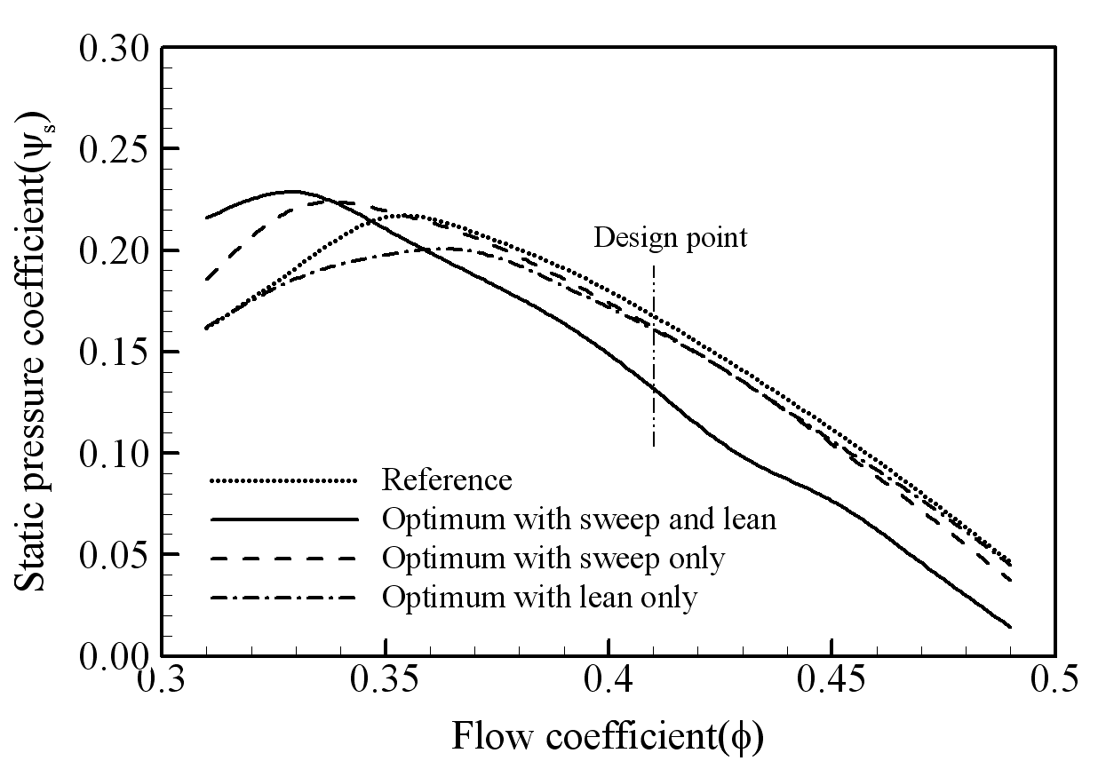
Figure 1. The caption heading for a figure should be placed below the figure and within figure/illustration width.

Use either SI (MKS) as primary units. English or CGS units may be used as secondary units (in parentheses). Avoid combining SI and CGS units. This often leads to confusion because equations do not balance dimensionally. If you must use mixed units, clearly state the units for each quantity that you use in an equation. Do not mix complete spellings and abbreviations of units. Spell out units when they appear in text.

REFERENCES
References should appear together at the end of the abstract, listed alphabetically by the last name of the first author. Thereafter sorting is made by co-authors and year. However, in the text, sorting is done by year (Dong et al., 2005; Gran, 1992). References in the text consist of the author's name and publication year in parentheses, as found in Dong et al. (2005). If several references are cited collectively, they are enclosed in parentheses with no additional parentheses around dates. All references listed should be cited in the text. Example reference citations are provided at the end of this paper.

Dong, N.C., Araki, H., Yamanishi, H., and Koga, K. (2005). Simulation of groundwater flow and environmental effects resulting from pumping. Environmental Geology, 47 (3), 361-374.
Donelan, M.A. (1978). Whitecaps and momentum transfer. NATO Conf. on Turbulent fluxes through the sea surface, wave dynamics, and prediction, Ed. A. Favre and K. Hasselmann, Plenum, NY, 273-287

